**MAULANA AZAD NATIONAL INSTITUTE OF TECHNOLOGY BHOPAL**

**DEPARTMENT OF CSE**

Name: Yashwant Patidar

Scholar Number: 191112243

Section: CSE 2

3rd SEM BTech

Subject: Principles of Programming Languages Lab - CSE 219

**Lab Assignment 2**

**Question 1:** WAP to use static, local, global variable in different functions and call that functions twice, then analyze the results and print final value of each variable.

**Program code:**

#include <iostream>

using namespace std;

int global_x=10; //global variable

static int static_x=20;//static variable

void func1(){

  global_x++;

  cout<<"Value of global_x in func1 is "<<global_x<<endl;

}

void func2(){

  static_x++;

  cout<<"Value of static_x in func2 is "<<static_x<<endl;

}

void func3(){

  int local_x=30;

  cout<<"Value of local_x in func3 is "<<local_x<<endl;

}

int main(){

  int local_x=0;//local variable

  cout<<"Before Calling any functions values are :"<<endl;

  cout<<"Local: "<<local_x<<"\tGlobal: "<<global_x<<"\tStatic: "<<static_x<<endl;

  cout<<"\nCalling the functions first time::"<<endl;

  //calling functions once

  func1();

  func2();

  func3();

  cout<<"\nAfter Calling the functions Once: "<<endl;

  cout<<"Local: "<<local_x<<"\tGlobal: "<<global_x<<"\tStatic: "<<static_x<<endl;

  cout<<"\nCalling the functions second time::"<<endl;

  //calling functions again

  func1();

  func2();

  func3();

  cout<<"\nAfter Calling the functions again: "<<endl;

  cout<<"Local: "<<local_x<<"\tGlobal: "<<global_x<<"\tStatic: "<<static_x<<endl;

}

**Output:**

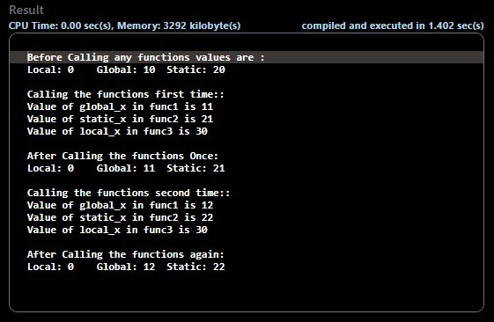

**Question 2:** WAP to define global variable which is accessed by main() and two other functions and then print the values of global variable in each function call.

**Program Code:**

#include <iostream>

using namespace std;

int global_x=10; //global variable

void func1(){

  global_x++;

  cout<<"Value of global_x in func1 is "<<global_x<<endl;

}

void func2(){

  global_x++;

  cout<<"Value of global_x in func2 is "<<global_x<<endl;

}

int main(){

  cout<<"Before Calling any functions value of global variable is: "<<global_x<<endl;

  cout<<"\nCalling the functions first time::"<<endl;

  //calling functions once

  func1();

  func2();

  cout<<"\nAfter Calling the functions Once: "<<endl;

  cout<<"Global: "<<global_x<<endl;

  cout<<"\nCalling the functions second time::"<<endl;

  //calling functions again

  func1();

  func2();

  cout<<"\nAfter Calling the functions again: "<<endl;

  cout<<"Global: "<<global_x<<endl;

}

**Output:**

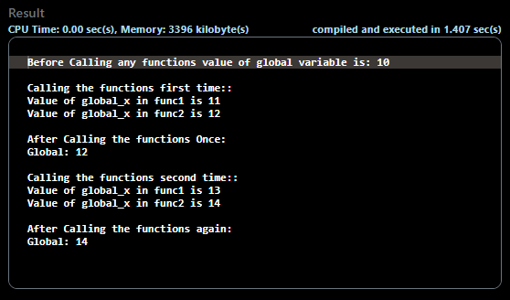

**Question 3:** WAP to compute the sum of all elements in a Z-matrix using pointers.

**Problem Code:**

#include <iostream>

using namespace std;

int main() {

    int n;

    cout<<"Enter size of matrix: ";

    cin>>n;

    int a[n][n],sum=0;

    cout<<"Enter elements of the matrix in row major: \n";

    for(int i=0;i<n;i++)

      for(int j=0;j<n;j++)

        cin>>a[i][j];

    //top row and bottom row sum

    for(int i=0;i<n;i++){

        sum+=a[0][i]+a[n-1][i]+a[i][n-1-i];

    }

    //subtracting the double counted elements at corners of the diagonal

    sum-=(a[0][n-1]+a[n-1][0]);

    cout<<"\nSum of Z matrix: "<<sum;

}

**Output:**

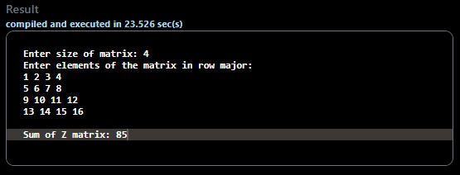

**Question 4:** WAP to calculate the factorial of n using recursion.

**Problem Code:**

#include <iostream>

using namespace std;

long long fact(long long n){

  if(n<=2) return n;

  return n*fact(n-1);

}

int main() {

    long long n;

    cout<<"Enter n for factorial: ";

    cin>>n;

    cout<<"\n"<<n<<" factorial is equal to "<<fact(n);

}

**Output:**

